ASSIGNMENT – 6

1. Write a Java program to create a method that reads a file and throws an exception if the file is not found

Program

import java.io.File;

import java.io.FileNotFoundException;

import java.util.Scanner;

public class FileReader

{

public static String readFile(String filename) throws FileNotFoundException {

File file = new File(filename);

Scanner scanner = new Scanner(file);

StringBuilder contents = new StringBuilder();

while (scanner.hasNextLine()) {

contents.append(scanner.nextLine()).append("\n");

}

scanner.close();

return contents.toString();

}

public static void main(String[] args) {

try {

String filename = "example.txt";

String contents = readFile(filename);

System.out.println("File contents:");

System.out.println(contents);

} catch (FileNotFoundException e) {

System.out.println("File not found: " + e.getMessage());

}

}

}

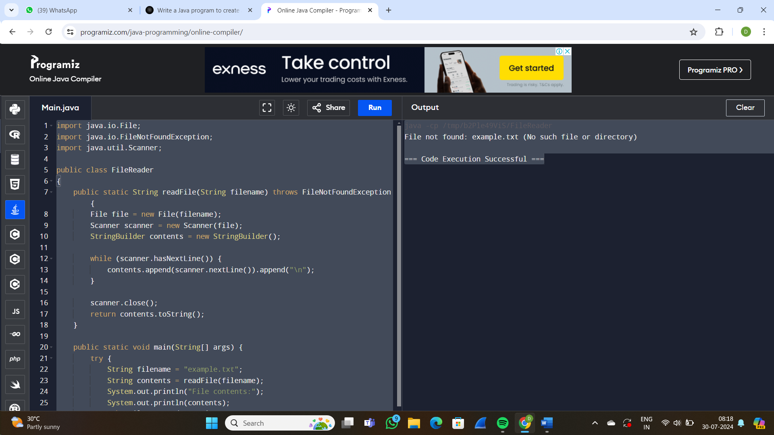

1. Write a Java program to create a class called Student with private instance variables student_id, student_name, and grades. Provide public getter and setter methods to access and modify the student_id and student_name variables. However, provide a method called addGrade() that allows adding a grade to the grades variable while performing additional validation.

Program:

import java.util.ArrayList;

import java.util.List;

public class Student {

private String student_id;

private String student_name;

private List<Double> grades;

public Student(String student_id, String student_name) {

this.student_id = student_id;

this.student_name = student_name;

this.grades = new ArrayList<>();

}

public String getStudent_id() {

return student_id;

}

public void setStudent_id(String student_id) {

this.student_id = student_id;

}

public String getStudent_name() {

return student_name;

}

public void setStudent_name(String student_name) {

this.student_name = student_name;

}

public List<Double> getGrades() {

return grades;

}

public void addGrade(double grade) {

if (grade < 0 || grade > 100) {

throw new IllegalArgumentException("Grade must be between 0 and 100");

}

grades.add(grade);

}

@Override

public String toString() {

return "Student [student_id=" + student_id + ", student_name=" + student_name + ", grades=" + grades + "]";

}

public static void main(String[] args) {

Student student = new Student("S123", "John Doe");

student.addGrade(80);

student.addGrade(90);

try {

student.addGrade(-10);

} catch (IllegalArgumentException e) {

System.out.println(e.getMessage());

}

System.out.println(student.toString());

}

}

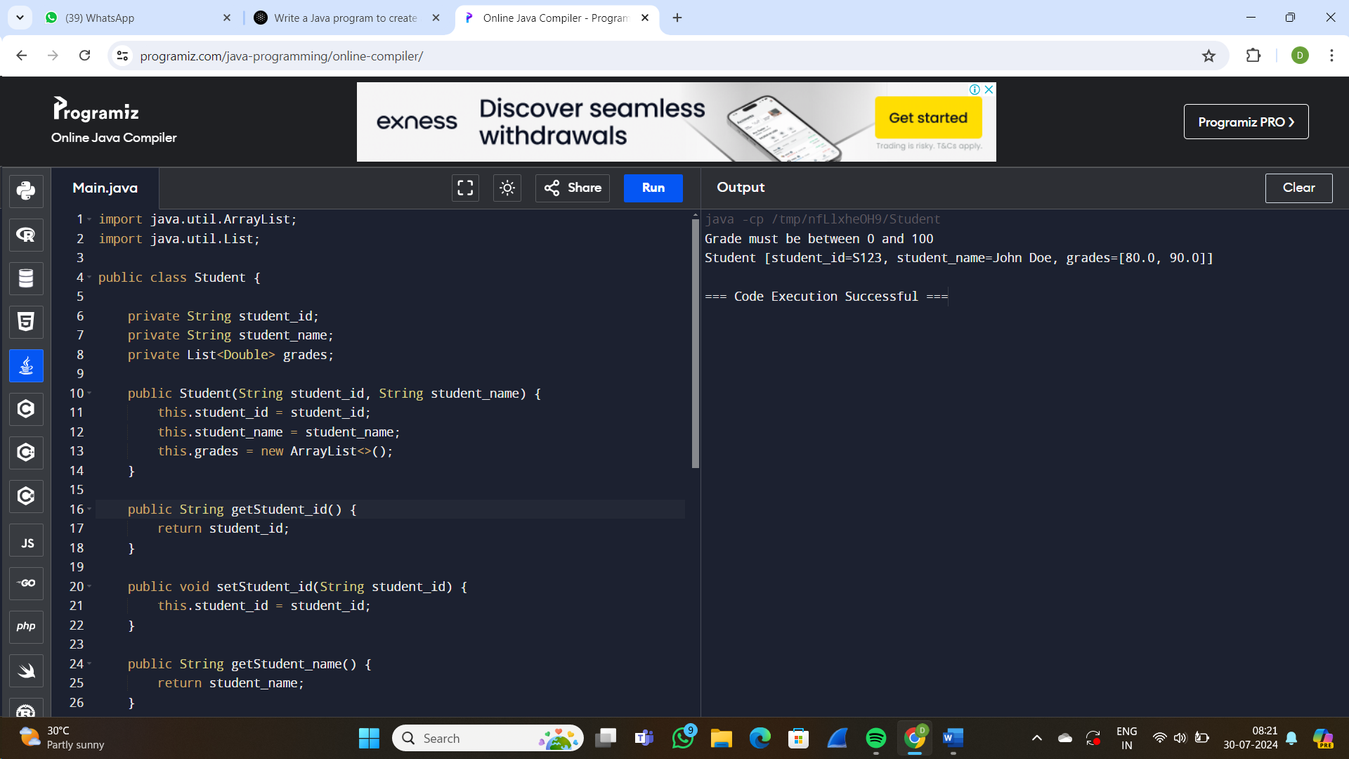

1. Write a JavaFX application with a text input field and a button. When the button is clicked, display the text entered in the input field in a label.

Program:

import javafx.application.Application;

import javafx.geometry.Insets;

import javafx.geometry.Pos;

import javafx.scene.Scene;

import javafx.scene.control.Button;

import javafx.scene.control.Label;

import javafx.scene.control.TextField;

import javafx.scene.layout.VBox;

import javafx.stage.Stage;

public class JavaFXApplication extends Application {

@Override

public void start(Stage primaryStage) {

// Create a text field

TextField textField = new TextField();

textField.setPromptText("Enter your text here");

// Create a button

Button button = new Button("Click me");

button.setOnAction(event -> {

// Get the text from the text field

String text = textField.getText();

// Create a label to display the text

Label label = new Label("You entered: " + text);

// Add the label to the scene

((VBox) textField.getParent()).getChildren().add(label);

});

// Create a vertical box layout

VBox root = new VBox(10);

root.setAlignment(Pos.CENTER);

root.setPadding(new Insets(10));

root.getChildren().addAll(textField, button);

// Create a scene and set the root node

Scene scene = new Scene(root, 300, 250);

// Set the scene to the stage

primaryStage.setScene(scene);

primaryStage.setTitle("JavaFX Application");

primaryStage.show();

}

public static void main(String[] args) {

launch(args);

}

}